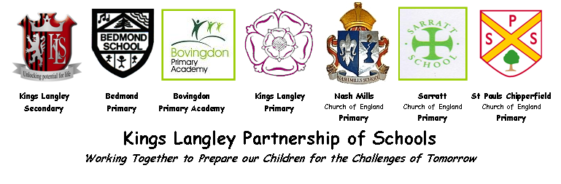

**Virtual Parenting Courses/Workshops**

**September – December 2020**

**Booking is essential**

**Due to the current circumstances your Family Support Team have arranged the following sessions to be given via telephone or zoom**

**If you would like to book onto any of these sessions or to find out more information, please contact**

**Emma Christie on 07538 232069 / 01442 278793 or email: christiee.gadesfs@kls.herts.sch.uk**

**Autism Support – 1:1 Advice Sessions**

**Date:** Tuesday 29th September 2020

**Time:** 9.30am – 10.00am, 10.05am – 10.35am, 10.40am – 11.10am and 11.15am – 11.45am

**What’s it about?** Jill Stevens, Specialist Teacher for Autism & Communication will be holding free 30 minute 1:1 advice for parents with children who have an Autistic Spectrum Disorder (ASD) Diagnosis or suspected ASD.

**Debt Management – 1:1 Advice Sessions**

**Date:** Thursday 8th October 2020

**Time:** 9.30am – 10.00am, 10.05am – 10.35am, 10.40am – 11.10am and 11.15am – 11.45am

**What’s it about?** CAP provides a free and comprehensive debt counselling service. They help local families overcome the difficulties of debt. As part of their service, they offer 1:1 advice, where you can speak confidentially to one of their fully qualified debt coaches to discuss the best options to get on top of your money worries.

**Housing 1:1 Advice Sessions**

***Dates:*** Tuesday 20th October 2020

***Time:*** 9.30am – 9.55am, 10.00am – 10.25am, 10.30am – 10.55am, 11.00am – 11.25am

***What’s it about?*** Speak to a member of Dacorum Borough Council Housing Team for a free 25-minute appointment who will offer advice and guidance to any housing queries.

**Autism Support – 1:1 Advice Sessions**

**Date:** Tuesday 3rd November 2020

**Time:** 9.30am – 10.00am, 10.05am – 10.35am, 10.40am – 11.10am and 11.15am – 11.45am

**What’s it about?** Jill Stevens, Specialist Teacher for Autism & Communication will be holding free 30 minute 1:1 advice for parents with children who have an Autistic Spectrum Disorder (ASD) Diagnosis or suspected ASD.

**Debt Management – 1:1 Advice Sessions**

**Date:** Thursday 26th November 2020

**Time:** 9.30am – 10.00am, 10.05am – 10.35am, 10.40am – 11.10am and 11.15am – 11.45am

**What’s it about?** CAP provides a free and comprehensive debt counselling service. They help local families overcome the difficulties of debt. As part of their service, they offer 1:1 advice, where you can speak confidentially to one of their fully qualified debt coaches to discuss the best options to get on top of your money worries.

***Housing 1:1 Advice Sessions***

***Date:*** Tuesday 1st December 2020

***Time:*** 9.30am – 9.55am, 10.00am – 10.25am, 10.30am – 10.55am, 11.00am – 11.25am

***What’s it about?*** Speak to a member of Dacorum Borough Council Housing Team for a free 25 minute appointment who will offer advice and guidance to any housing queries.

**Autism Support – 1:1 Advice Sessions**

**Date:** Tuesday 15th December 2020

**Time:** 9.30am – 10.00am, 10.05am – 10.35am, 10.40am – 11.10am and 11.15am – 11.45am

**What’s it about?** Jill Stevens, Specialist Teacher for Autism & Communication will be holding free 30 minute 1:1 advice for parents with children who have an Autistic Spectrum Disorder (ASD) Diagnosis or suspected ASD.

***Gade Schools Family Support are now a Foodbank collector, if you would like to make a contribution, donations would be gratefully received. Please bring any items into our office.***

[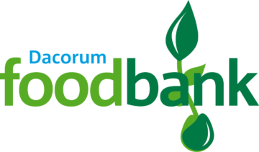](https://dacorum.foodbank.org.uk/)